Install the Stackstorm Application
bash <(curl -sSL https://stackstorm.com/packages/install.sh) --user=st2admin --password=Ch@ngeMe

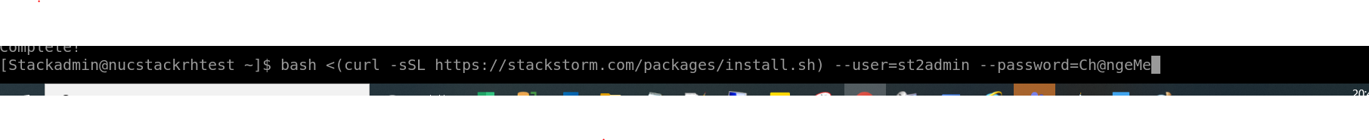

While installing , getting any error like below.

Error: Failed to download metadata for repo 'epel-modular': Cannot prepare internal mirrorlist: Status code: 404 for https://mirrors.fedo
raproject.org/metalink?repo=epel-modular-8.4&arch=x86_64&infra=$infra&content=$contentdir (IP: 8.43.85.73)

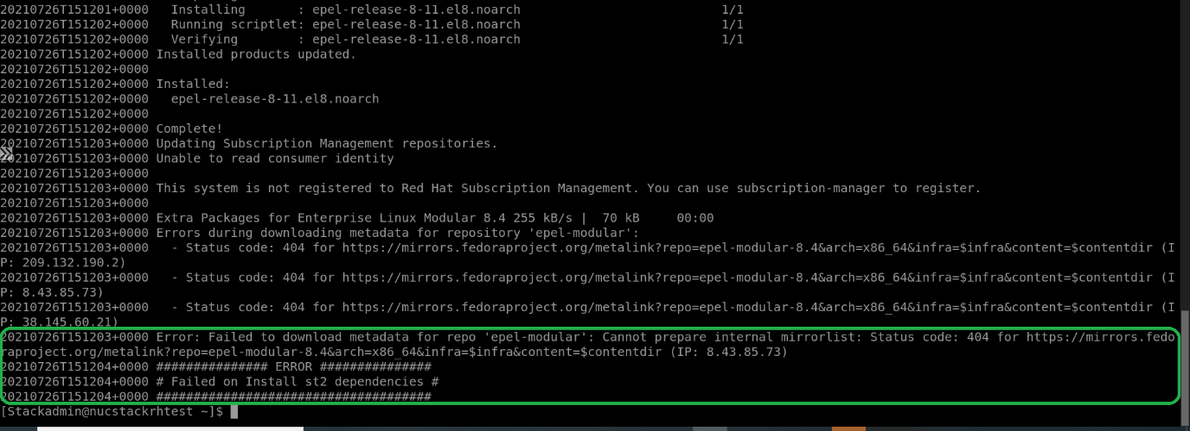
Getting above error, run the below command

sudo sed -i.bak 's/\$releasever/8/g' /etc/yum.repos.d/epel*.repo

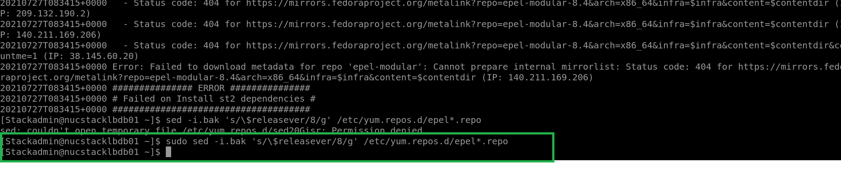

Again needs to start the installation.

bash <(curl -sSL https://stackstorm.com/packages/install.sh) --user=st2admin --password=Ch@ngeMe

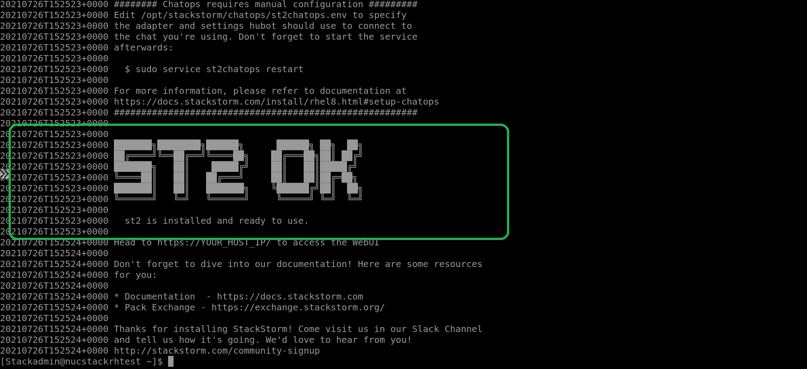
Successfully installed Stackstorm.

Install the puppet-bolt

Command: sudo yum install puppet-bolt

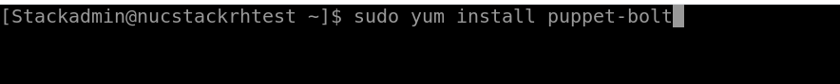

After entered, if you get the below error,

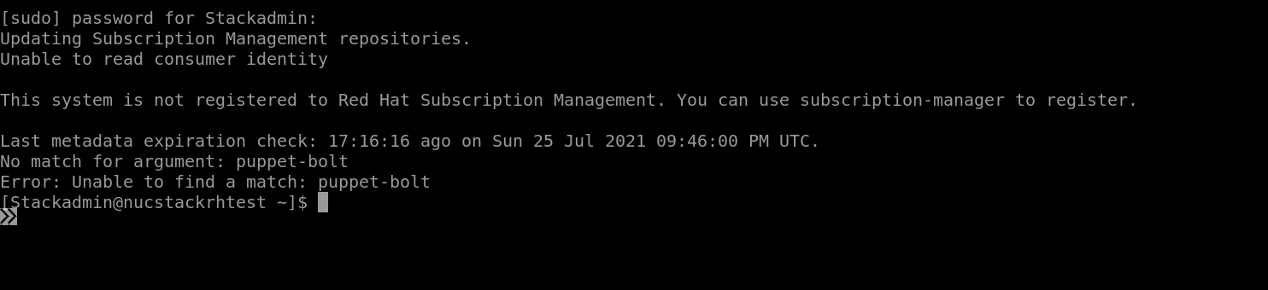

Then run the below command

sudo rpm -Uvh https://yum.puppet.com/puppet-tools-release-el-8.noarch.rpm

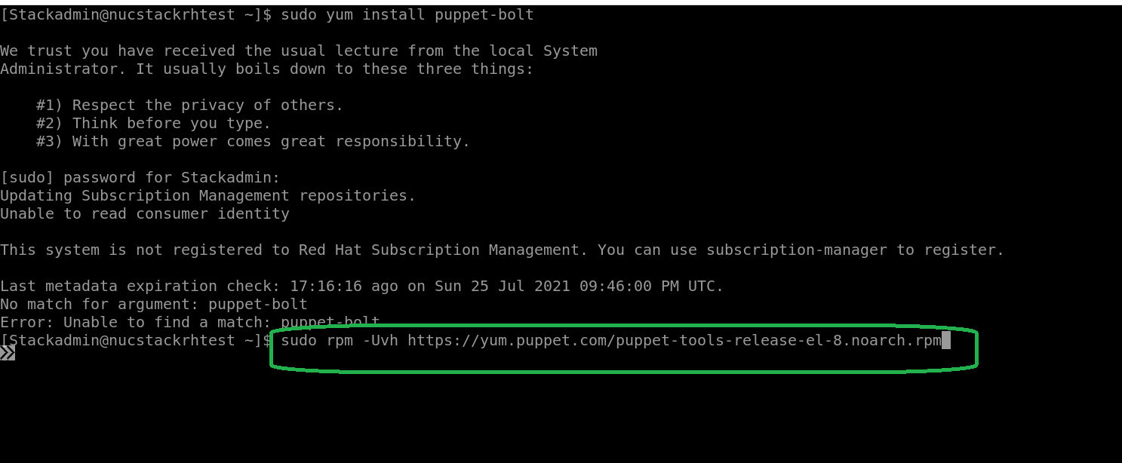

After the yum repo updated

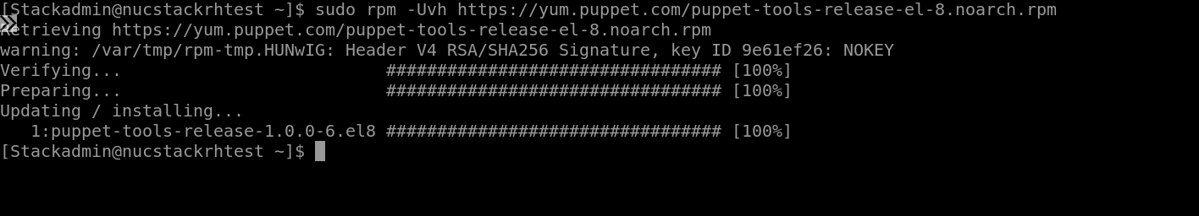

Now run the below command
sudo yum install puppet-bolt
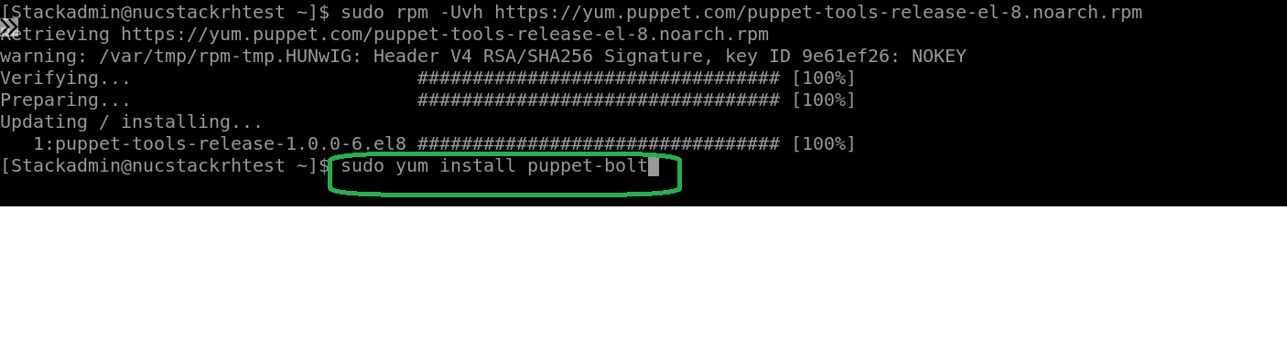

Type “y” & hit the enter
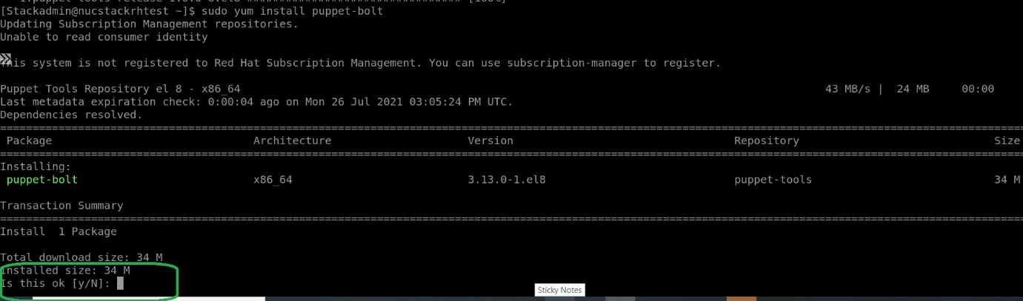

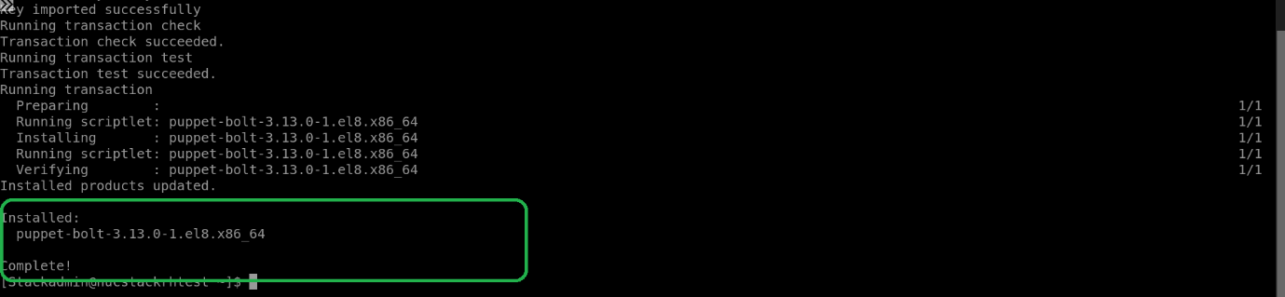

Now the puppet- bolt installed.

Install the bolt module
sudo /usr/local/bin/bolt module install

If the command took more than 5 mins, please cancel the process (ctrl+c)
Create the Puppetfile in /opt/stackstorm/packs/ntt_monitoring/ntt_monitoring
Sudo vi Puppetfile

# This Puppetfile is managed by Bolt. Do not edit.
# For more information, see https://pup.pt/bolt-modules

# The following directive installs modules to the managed moduledir.
moduledir '.modules'

mod 'stackstorm/st2', '2.1.0'
mod 'jamtur01/httpauth', '0.0.6'
mod 'puppetlabs/stdlib', '5.2.0'
mod 'puppetlabs/apt', '7.7.1'
mod 'puppetlabs/yumrepo_core', '1.0.7'
mod 'puppet/epel', '3.0.1'
mod 'saz/sudo', '6.0.0'
mod 'puppet/python', '4.1.1'
mod 'puppetlabs/inifile', '4.4.0'
mod 'puppet/mongodb', '3.1.0'
mod 'puppet/rabbitmq', '10.3.0'
mod 'ghoneycutt/facter', '3.5.0'
mod 'puppet/selinux', '3.4.0'
mod 'puppet/nginx', '1.1.0'
mod 'puppet/nodejs', '7.0.1'
mod 'npwalker/recursive_file_permissions', '0.6.1'
mod 'puppetlabs/translate', '2.2.0'
mod 'puppet/archive', '4.6.0'
mod 'camptocamp/systemd', '2.12.0'
mod 'puppetlabs/concat', '6.4.0'

once create the Puppetfile, again run the below command.
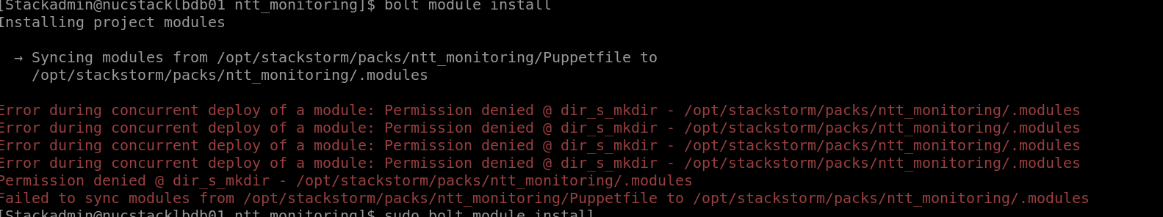

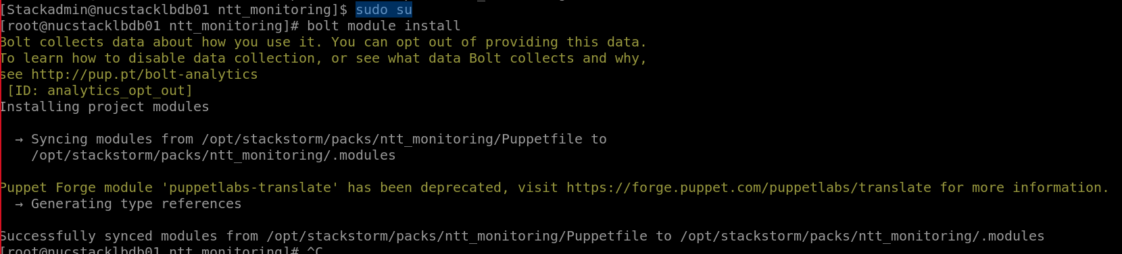

sudo /usr/local/bin/bolt module install
After successful, we got the below message.
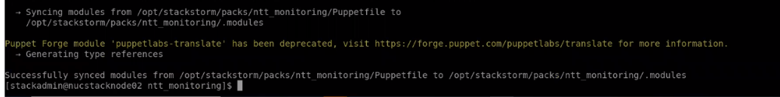

TypeError: write() argument must be str, not bytes on bolt run :

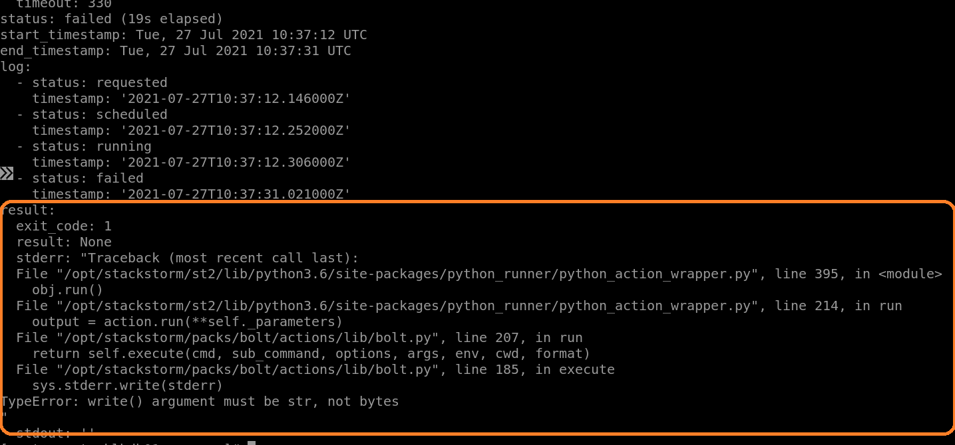

Open the file /opt/stackstorm/packs/bolt/actions/lib/bolt.py
Needs to modify the coding on the below marked line as below .
sys.stderr.write(stderr.decode('utf-8'))
Before change :
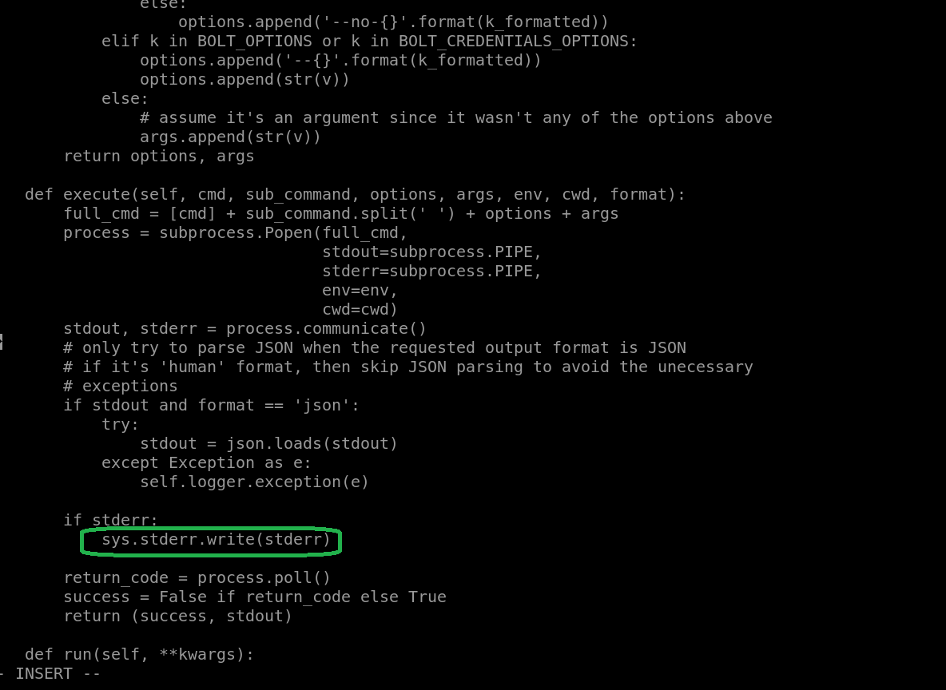

After Change :
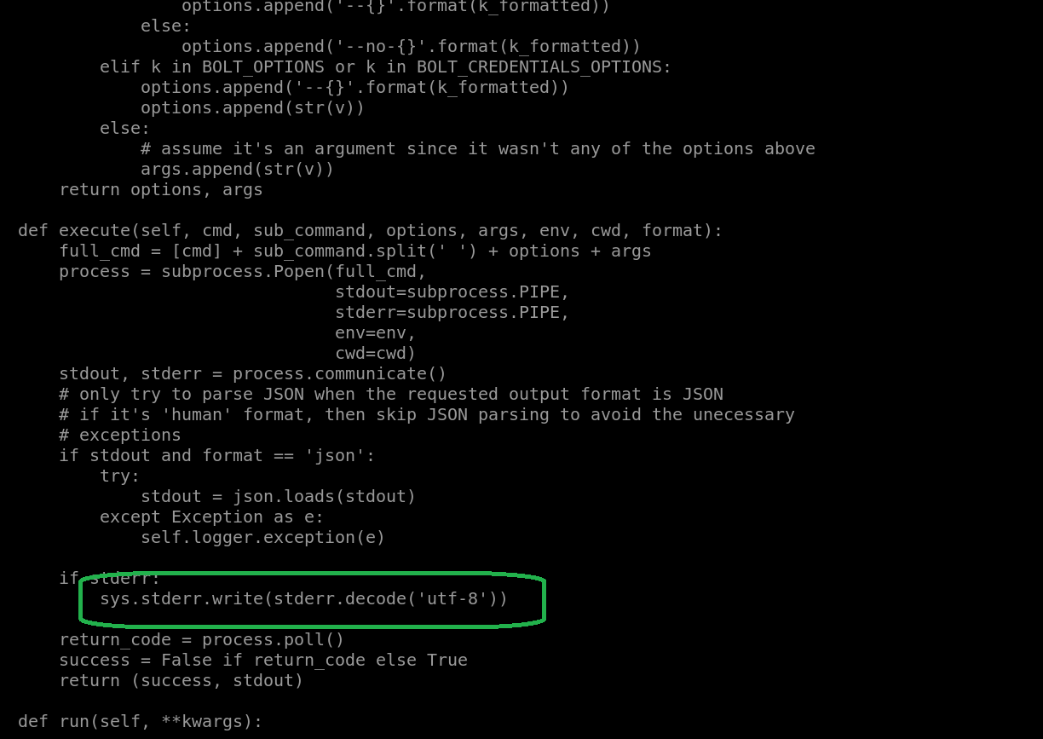

Remove the redis
sudo systemctl stop redis
sudo systemctl disable redis

ntt_monitoring install – Pack install issue :

while installing the ntt_monitoring ,got the below error ( download pack failed)

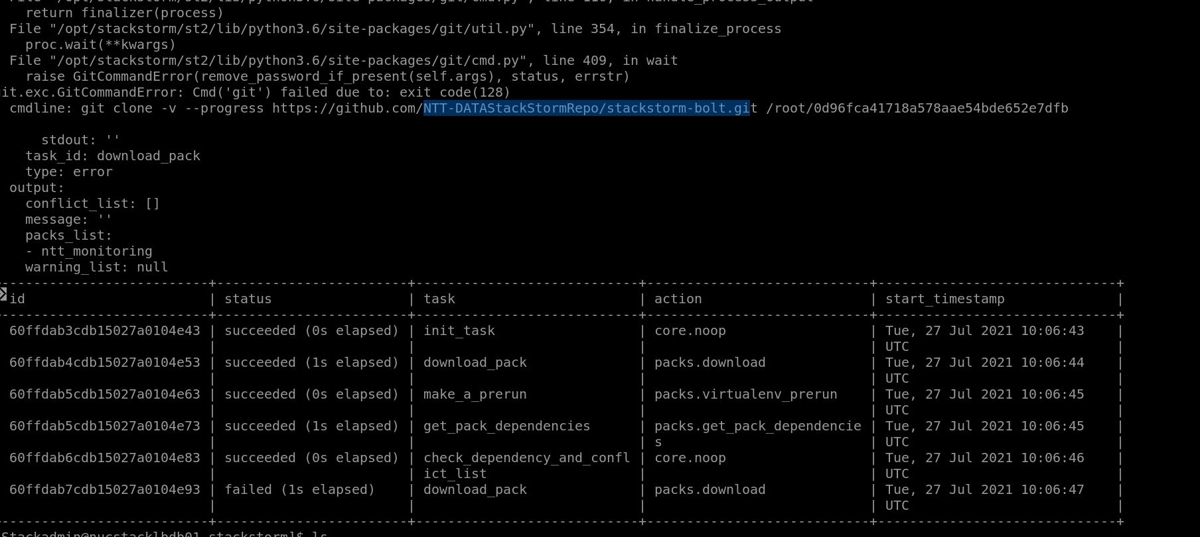

Then install the below pack manually.
# install the Bolt
st2 pack install bolt
# install the SQL
st2 pack install sql

install the Bolt
command : st2 pack install bolt

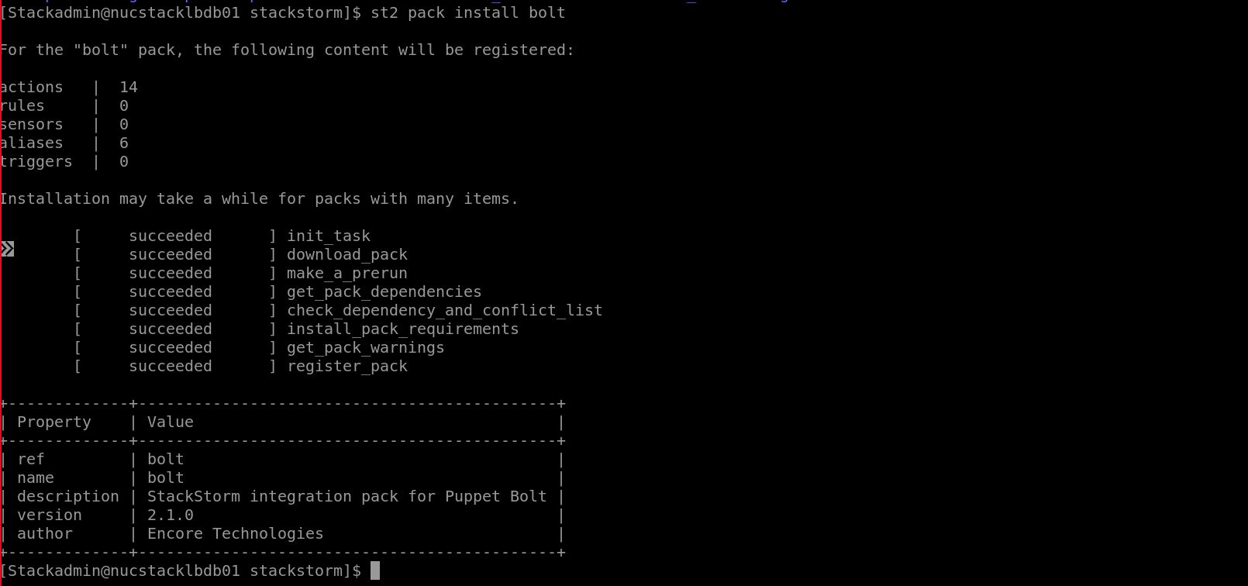

Install the sql
Command : st2 pack install sql
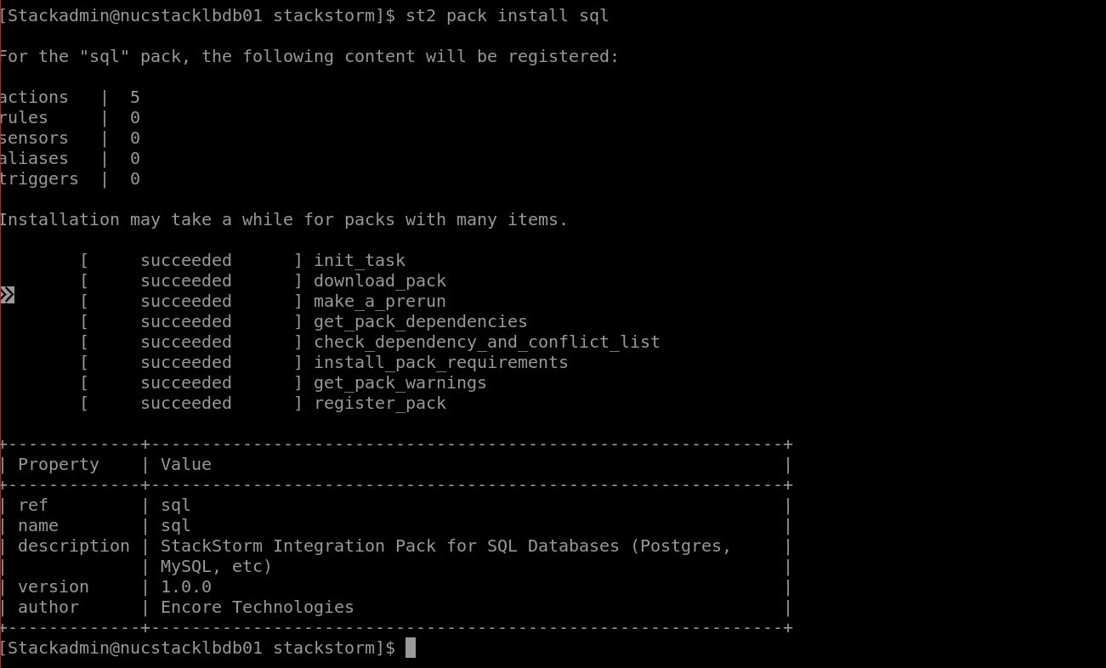

Once done the above 2 pack installation, needs to install ntt_monitoring pack
Command : sudo st2 pack install file:///opt/stackstorm/stackstorm-ntt_monitoring

